**Abstract**

Fovea is an essential characteristic of our eye as it is the sight of sharpest vision located in the macula lutea of the retina. Systematic detection of fovea location is required for analysis of diabetic macular edema. The following study aims to predict the location of fovea centralis from colour fundus images based on Ensemble method and VGG-16-layer model to improve the overall efficiency of the earlier model. //using an Ensemble Method of CNN and VGG16 model. Furthermore, the images have been pre-processed using the concept of filters to extract better features from the images. Comparative analysis states that the proposed method is more efficient than the earlier methods in terms of accuracy and simplicity.

**Introduction**

The retina is a thin layer of tissue which is located near the optic nerve. Main purpose of retina is to receive light that the lens has focused, convert the light into neural signals, and send these signals on to the brain for visual recognition. Fovea, often referred to as the Blind spot is the responsible for sharp central vision. It is an area approximately 1.5 mm in diameter within the macula lutea where the retina thins out greatly because of the oblique shifting of all layers except the pigment epithelium layer. Any damage to fovea can cause blurred vision and thickening distorts vision.

Macular edema is the build-up of fluid in the macula, an area in the centre of the retina. Fluid build-up causes the macula to swell and thicken, which distorts vision.

Diabetic Macular Edema (DME) is an accumulation of fluid in the macula part of the retina that controls our most detailed vision abilities—due to leaking blood vessels. In order to develop DME, you must first have diabetic retinopathy. Diabetic retinopathy is a disease that damages the blood vessels in the retina, resulting in vision impairment. Left untreated, these blood vessels begin to build up pressure in the eye and leak fluid, causing DME. DME usually takes on two forms:

* Focal DME, which occurs because of abnormalities in the blood vessels in the eye.
* Diffuse DME, which occurs because of widening/swelling retinal capillaries (very thin blood vessels).

Diabetic Retinopathy and DME are common problems for diabetics. Roughly 8% of the U.S. population is diabetic, and about 28% of those diabetics have eye trouble because of it.

**Methods Attempted**

In order for detection of the fovea location, the given images were converted into pixel array to predict the location coordinates of fovea using the CNN model. Around 400 images were used to train this model and it did predict the y coordinates with good accuracy with deviation of 0.5%. In case of x coordinates, 80% of the cases, model is able to predict x coordinates properly, but in few cases, there are substantial deviations.

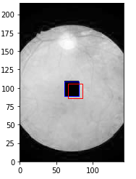So, in order to avoid these deviations a new model was created to predict the rectangle around the fovea and mark the center around. Now this will be further compared with the given fovea location.

**About the image**: The image has been resized maintaining the aspect ratio and converted into grayscale image.

**Blue box**- Represents area around actual location

**Red box**- Predicted box

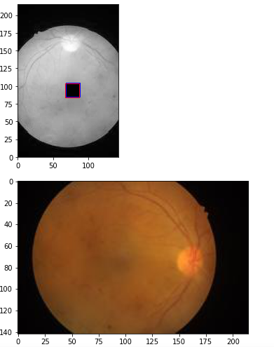

In order to increase the efficiency further, the following three were implemented.

1)Increased the number of iterations to train the model

2)Increased the number of Dense layers.

3)Removed the Nonlinear Activation Function.

The previous model predicted very close box coordinates for most of the cases. But this present model overcomes this issue for which the above changes were implemented.

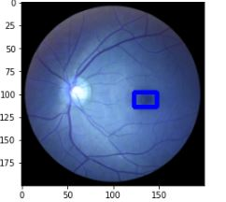Also, template matching method was adopted and the following were the steps followed. Firstly, the image is resized and converted to Gray scale. Now using the template matching statistical method, the maximum correlation between the input and the image and the template is found.

Using the below mentioned, the bottom right coordinates is found

Topleft =maxloc

(h,w)=templategray.shape

Now in order to obtain the centre of the Rectangle,

Centre = (topleft +topright)/2

**Proposed Method**

With better generalisation and better accuracy as the key factors in mind, the methods adopted were Transfer learning model with VGG-16 model and CNN. The CNN method used image representation, edge detection, striding and padding. Three concentric circles were made to detect the fluid spread extent of the fluid in the fovea using the above models. Now for accurate detection of fovea location, radius of extent of three concentric circles to be detected. This in turn gives us depth about the fluid spread extent and allows us to set restrictions as per the thickening constraints. It can be suspected if the foveal thickness is greater than 252 μm and macular thinning can be suspected if **foveal** thickness is less than 172 μm.

The output layer changes the x, y, z coordinates?. For location prediction, once the image is resized, it is passed through multiple 2-D convolutional Layers. First layer consists of 64 units and (3,3) kernels with “Glorot Uniform“as the weight initializer function. Further, it is passed through a dropout layer with factor of 0.2 . This is used in order to overcome overfitting and to make the model more Robust. Next it is passed through the Second CNN layer with 32 units and (3,3) kernels with “He normal” as the weight initializer followed by a dropout layer with 0.2 factor. Finally, it is passed through the last layer of Convo2-D layer with 16 units and (3,3) kernel with “He uniform” as the weight initializer . The above obtained is passed through a flatten layer and two Dense layers. The first layer consists of 8 units with “RELU “as the activation function whereas the final dense layer, which is the output layer consist of only one unit and uses “Linear” activation function. for a convolutional 2-D layer, there are 64 units and (3,3) kernels, so the weight initialises and (0,2) layer is dropped out. Now again, the for convolutional 2-D layer, with 32 units and (3,3) kernels and them 16 units and (3,3) kernel size, the process of weight initialising is repeated and a flattened layer is developed. The dense layer of 8 units allows activation of RELU and dense layer of 1 unit allows activation of Linear.

In case of Transfer Learning model, the image was first resized then passed through the VGG16 model without the last layer. The values obtained here are passed through the flatten layer followed by two dense layers with “RELU” and “LINEAR” activation function respectively .The result is obtained from the second layer.

Then average of the results obtained from the above two models are taken to make the model more generic.

The above method is also used to predict the final location with maximum accuracy.

**Analysis and Results**

Therefore, we were able to predict the fluid extent radius using the ensemble method used. The thickening ranges as mentioned by the standard, can be used to further classify the into three broad categories.

In case of fluid spread through three overlap, it can be considered as worst case corresponds to 80% spread, similarly, fluid spread across two overlap is considered a medium case (50% spread) and spread across only first circle or below is considered the best case (15% spread).